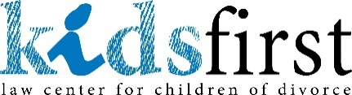
AUTHORIZATION FOR DIRECT PAYMENT VIA ACH

I authorize Kids First Law Center, (“KIDS FIRST”) to electronically debit my account (and, if necessary, electronically credit my account to correct erroneous debits) at the depository financial institution named below. I agree that ACH transactions I authorize comply with all applicable law.

Financial Institution Name
Routing Number*
Account Number*

* Please attach a copy of a voided check for verification of the above information.

Select One:
□ Checking Account □ Savings Account

Amount of Debit(s) | $
Frequency: | □ weekly □ biweekly □ monthly
If Monthly: | □ 1st of month □ 15th of month □ last day of month
Start Date:

Select One:
□ I understand that this authorization will remain in full force and effect until I notify KIDS FIRST in writing by mail to 420 6th St. SE, Ste. 160, Cedar Rapids, IA 52401 that I wish to revoke this authorization. I understand that KIDS FIRST requires at least 3 days prior notice in order to cancel this authorization.

OR

□ I understand that this authorization will remain in full force and effect until the amount of $ has been received by KIDS FIRST. I will notify KIDS FIRST in writing by mail to 420 6th St. SE, Ste. 160, Cedar Rapids, IA 52401 if I wish to revoke this authorization. I understand that KIDS FIRST requires at least 3 days prior notice in order to cancel this authorization.

Name
Date |  | Signature

